Creativity Assignment: Nature, Creativity and Creative Thinking
Melody Kirabo
HUMN 14857G
Due: Wednesday, September 24th

Part A: Torrance Test for Creative Thinking
Drawing and Relaxed Attention
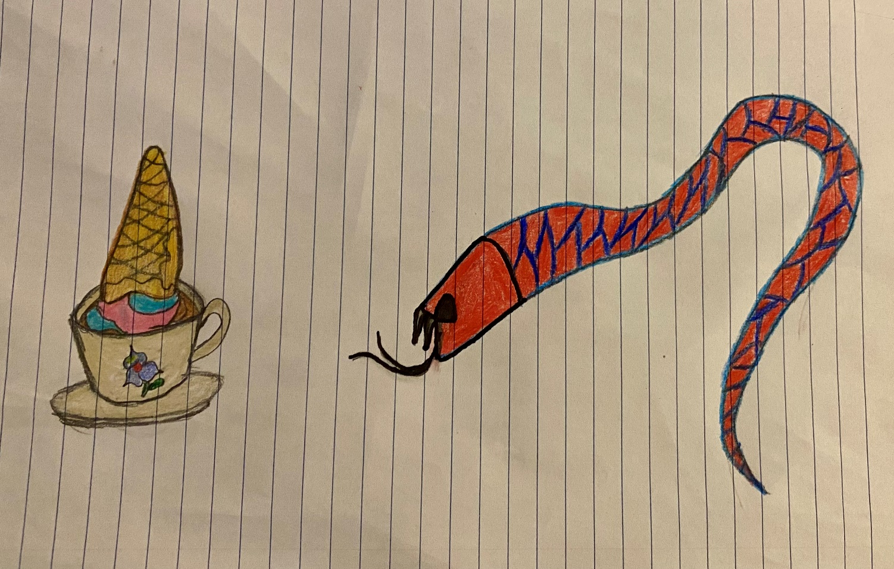
Title: The Serpent and the Sundae spell
Once upon a time, in a quiet garden filled with violet blossoms, a mysterious snake slithered silently toward a forgotten teacup sitting on a mossy table. But this was no ordinary teacup. It held a magical sundae, topped with rainbow scoops and a golden waffle cone. Legend said that whoever took a bite from the sundae would gain the power to speak to animals. The curious snake, lured by the scent of sweetness, took a tiny lick and suddenly, it whispered, “Thank you,” in perfect English. The world would never be the same again.

Part B: Reading, Reflection, and Responses on Nature, Creativity and Creative Thinking
1-3. Time in Nature and Reflection

Reflection
On a bright and peaceful afternoon, I spent about 20 minutes sitting on a floating dock by Centennial Park Barrie The view was stunning with clear blue skies, calm water stretching far into the distance, and the distant outline of buildings along the shore. I simply sat, breathed deeply, and allowed myself to enjoy the moment. With no distractions around me, I felt deeply relaxed and refreshed. I noticed how my mind started to wander gently, making creative connections and ideas flow more naturally. Being outside in nature allows me to disconnect from stress and technology and reconnect with my inner calm. I often find that time in nature helps boost my mood, clear my thoughts, and recharge my creativity. It reminds me of the importance of slowing down and being present in the moment.
4. Reading: Carolyn Gregoire, “The New Science of the Creative Brain on Nature”
5a. Three Benefits of Our “Brains” on Nature
Gregoire identifies three main cognitive benefits of spending time in nature:
- Restores mental energy: Nature provides relief from constant digital and sensory stimulation, allowing the prefrontal cortex to rest and thereby improving focus and creativity (Gregoire, 2016, para. 7).
- Boosts creativity: A 2012 study found that backpackers performed 50% better on creative problem-solving tests after four days in nature, suggesting that time in natural environments enhances creativity (Gregoire, 2016, para. 6).
- Reduces stress: Time in nature is associated with reduced stress and increased psychological well-being, providing a break from overstimulation and promoting a state of relaxed awareness (Gregoire, 2016, paras. 9-10).
5b. Importance of the Imagination (Default) Network to Creativity
The Imagination Network, also known as the Default Mode Network, is crucial for creative thinking. This network activates when we are not focused on a specific task like when daydreaming, walking in nature, or relaxing. It draws on different parts of the brain, including the hippocampus (which stores memories) and the medial prefrontal cortex (which supports self-reflection and planning) (Gregoire, 2016, para. 13).
According to neuroscientist David Strayer, when the prefrontal cortex quiets down, the imagination network lights up, often resulting in creative insights (Gregoire, 2016, para. 12). This explains why people frequently experience “aha” moments during undemanding activities such as walking or showering (Gregoire, 2016, para. 14). It is this restful, open mental state that supports imaginative thinking and helps generate new ideas.
5c. Three Activities That Activate the Imagination Network
Three activities mentioned in the article that help activate the Imagination Network are:
- Walking in nature: This provides gentle stimulation and allows the mind to wander freely, which activates the imagination network (Gregoire, 2016, para. 14).
- Doing routine tasks: Activities like showering or washing dishes give the brain a break and create space for creative thoughts to emerge (Gregoire, 2016, para. 14).
- Experiencing soft fascination: Being in a relaxed natural setting like watching leaves fall or water ripple gently holds attention without being mentally taxing, which supports imaginative thinking (Gregoire, 2016, para. 21).
5d. Ideal State to Activate the Imagination Network
The ideal state for activating the imagination network is one of “soft fascination,” which occurs during calm and mildly engaging activities like walking, canoeing, or watching natural scenery (Gregoire, 2016, para. 21). In this state, attention is gently held but not overwhelmed, creating the mental space for the imagination network to engage.
Strayer explains that this “gentle capturing of attention” allows the mind to wander and come up with creative solutions (Gregoire, 2016, para. 21). Additionally, when the prefrontal cortex is at rest such as during time in nature, the imagination network becomes more active, leading to flashes of insight (Gregoire, 2016, para. 12).
5e. Awe and Its Role in Creativity
Gregoire defines awe as “a sense of wonder and smallness in the face of something greater than oneself” (Gregoire, 2016, para. 17). This emotion helps stimulate creativity by encouraging expansive thinking allowing individuals to move beyond their usual thought patterns and see the world from new perspectives (Gregoire, 2016, para. 18).
One way to feel awe is by viewing stunning natural landscapes, like oceans or mountains. According to a 2012 study from Tel Aviv University, looking at expansive images (like galaxies or wide-open spaces) increased creativity in children by helping them shift from local to expansive thinking (Gregoire, 2016, para. 18).
6. References (APA Style)
Carolyn Gregoire (2016) “The New Science of the Creative Brain on Nature” Retrieved from https://www.outsideonline.com/health/training-performance/new-science-creative-brain-nature/

