Foursight Model Booklets - Elder Food Security Challenges
SOCS10172GD: Principles of Creative Problem Solving
Patricia Marshall
August 8th, 2021

Miro Board Link: https://miro.com/welcomeonboard/Y1RiNjBNeGRWR0JFZVJMQld3NG85UHdpbEQwSWdmNzFMTHVyeXZXaVgzczB6cnR1N1hHWWF0SGVraGNVcDlNanwzMDc0NDU3MzYwMTQwNjgxMjc4
Clarification Stage of the Creative Problem-Solving Process
Exercise 1: Take Stock
Purpose: To identify strengths and areas for improvement regarding elder food security...more specifically, volunteer engagement
Instructions:
Diverge:
Step 1. On a Miro board, brainstorm things that are going well (15) and things that aren’t going so well (15) regarding elder food security. Please use stick ‘em up brainstorming (i.e., brainstorming with post-it stickies).
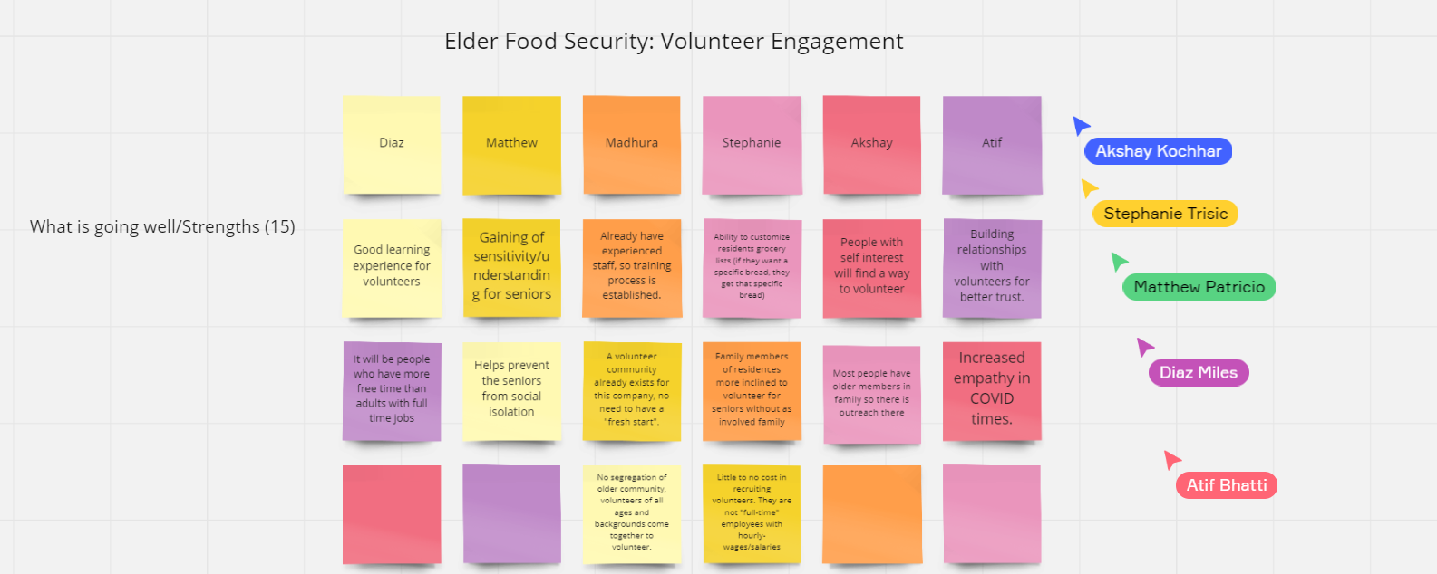
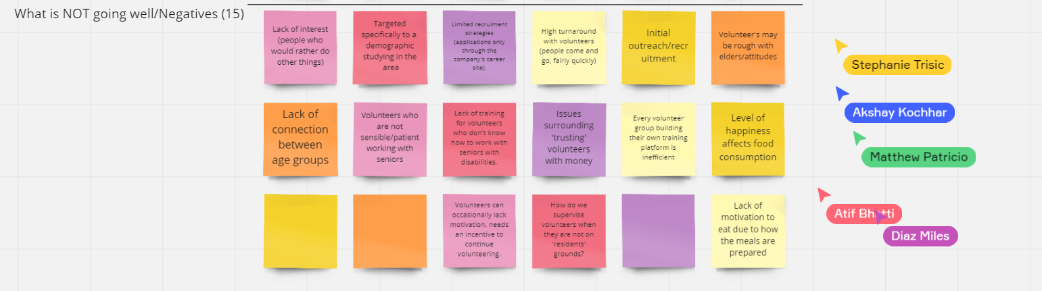
Screenshot taken by: Madhura Mitra

Converge:
Step 2.
- Rate each idea/issue on a scale of 1-3 and add your rating to each stickie. For example, No online food service (2)
  - 1 = low impact, 2 = moderate impact, 3 high impact
Step 3. Review your ratings and identify the top 5 most important strengths (things going well) and 5 most important negatives (things that aren’t going so well) – and tag them with a dot sticker or an asterisk (*).
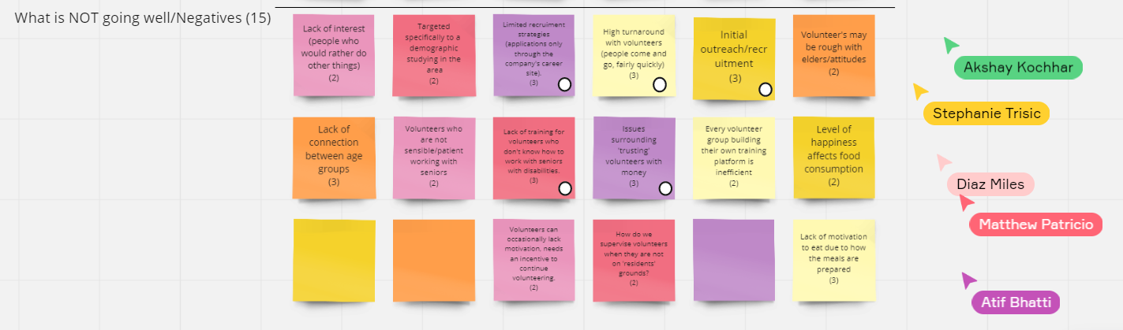
Step 4. Screenshot your idea list and paste it here for your master copy of the exercise booklet. Be sure all team member cursors are in the shot.
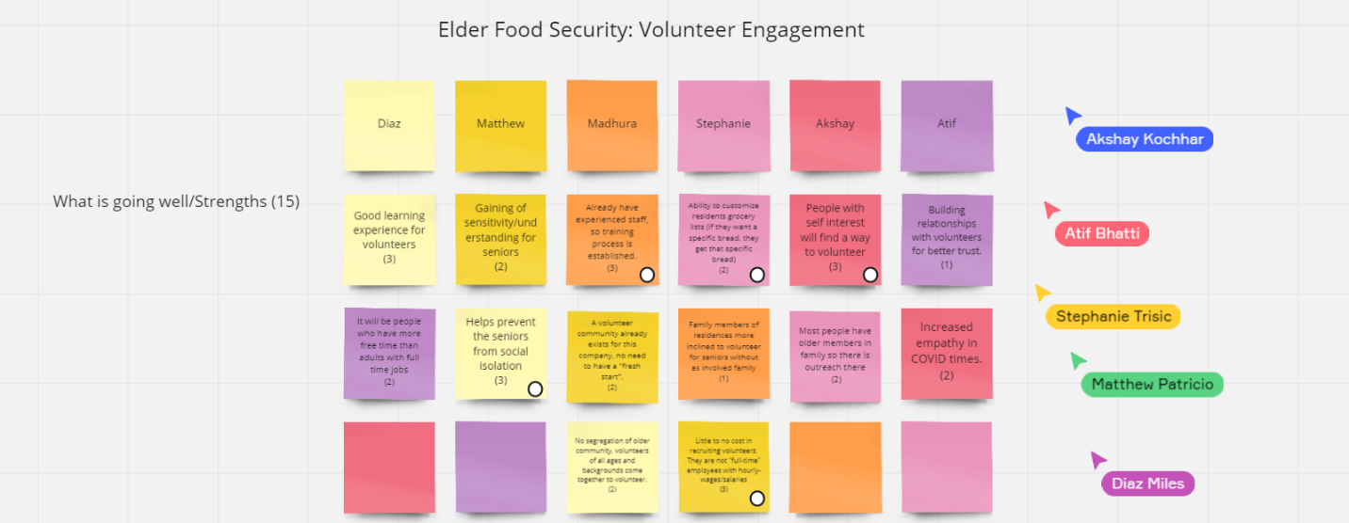
Screenshot taken by: Madhura Mitra

Step 5. List your top 5 important issues on each side in Table 1 below.
Table 1. Important Issues regarding elder food security
Strengths (rating) | Negatives (rating)
People with self interest will find a way to volunteer (3) | Initial outreach/recruitment (3) *
Already have experienced staff, so training process is established (3) | Lack of training for volunteers who don't know how to work with seniors with disabilities (3)
Helps prevent the seniors from social isolation (3) | High turnaround with volunteers (people come and go, fairly quickly) (3) *
Ability to customize residents’ grocery lists (if they want a specific bread, they get that specific bread) (2) | Issues surrounding 'trusting' volunteers with money (3)
Little to no cost in recruiting volunteers. They are not "full-time" employees with hourly wages/salaries (3) | Limited recruitment strategies (applications only through the company's career site) (3) *

Step 6. In Table 1, review your ratings and identify the top 3 most important negatives – the things that aren’t going so well and tag them with asterisks (*).

Step 7.
Finally,
- Select a single most important issue that you wish to take to the Ideation Stage and work on for the rest of this project. Make sure it is from your list of ‘things that aren’t going well’.
- In Table 1, tag it in some way to signify selection (e.g., Bold it; Highlight it), and
- Type it in Table 2 below. This is your Clarified Problem
Table 2: Clarified Problem

Clarified Problem
Topic: Initial outreach/recruitment.
Question: How can we find new areas, methods, and means to source and motivate volunteers?
How can we address the lack of awareness for these volunteering opportunities?
How can we find new ways to attract more volunteers?

Ideation Stage of the Creative Problem-Solving Process
Exercise 1: Generate possibilities
Now that you have your clarified problem you are set up to generate possible solutions. You are ready for Ideation.
During ideation, you will
- Diverge: Generate many options, and then
- Converge: Narrow possibilities
Instructions:
Step 1. To start, carry over and write your clarified problem (from the Clarify booklet) in Table 1 below.
Table 1. Ideation Question
Clarified Problem
How can we find new areas, methods, and means to source and motivate volunteers?

Step 2. Using the Stick’em Up brainstorming method (brainstorming with post-it notes), come up with 30 potential solutions (20 if working alone) to your problem:
- Shoot out ideas that could address your challenge
- As you go, write them on sticky notes on your team’s Miro board, and
- Remember to defer judgement. (i.e., nod it in, write it down, re-ask the question)
Step 3. Once you have completed your brainstorming,
- Screenshot your array of ideas and paste it here for your master copy of the exercise booklet. Be sure that every team member’s Miro cursor is in the shot.

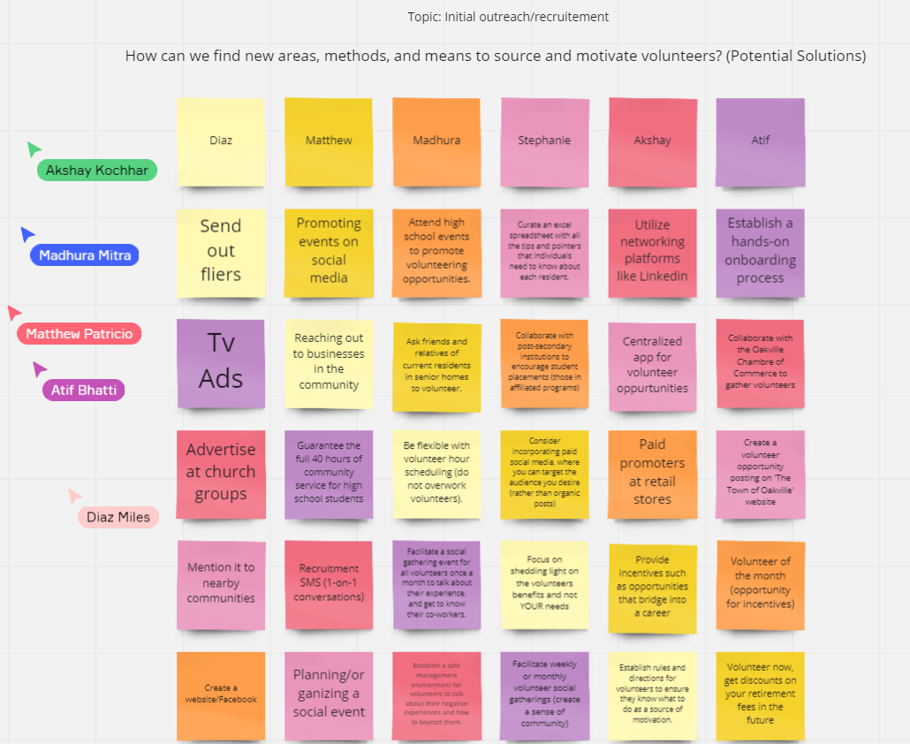
Screenshot taken by: Stephanie Trisic

Exercise 2: Narrow options
In the last exercise, you used divergent thinking (i.e. brainstorming) to come up with lots of potential options to address your ideation question.
Next, use convergent thinking to narrow the possibilities.
Instructions:
To start, Get Organized.
Step 1. On your Miro board, and as a team, sort your ideas into clusters/categories that make sense to you (at least 5 categories)
Step 2. Name each cluster/category, and
- add different coloured post-it notes as headings to your categories.
Next, Evaluate.
Step 3. Rate each idea on a scale of 1-5, in terms of IMPACT – how well it would solve your problem. You are rating all 30 ideas on your Miro board. Make sure the ratings are clearly visible.
- Note that a rating of 1 = very low impact, and 5 = very high impact
- For example, “online ordering and delivery from Tim Hortons 30 minutes before class (4)”
Finally, Select.
Step 4. Tag with a dot sticker (or star) the 3 highest rated ideas, and then
- take a screenshot of your sorted and rated ideas. Be sure that every team member’s Miro cursor is in the shot.

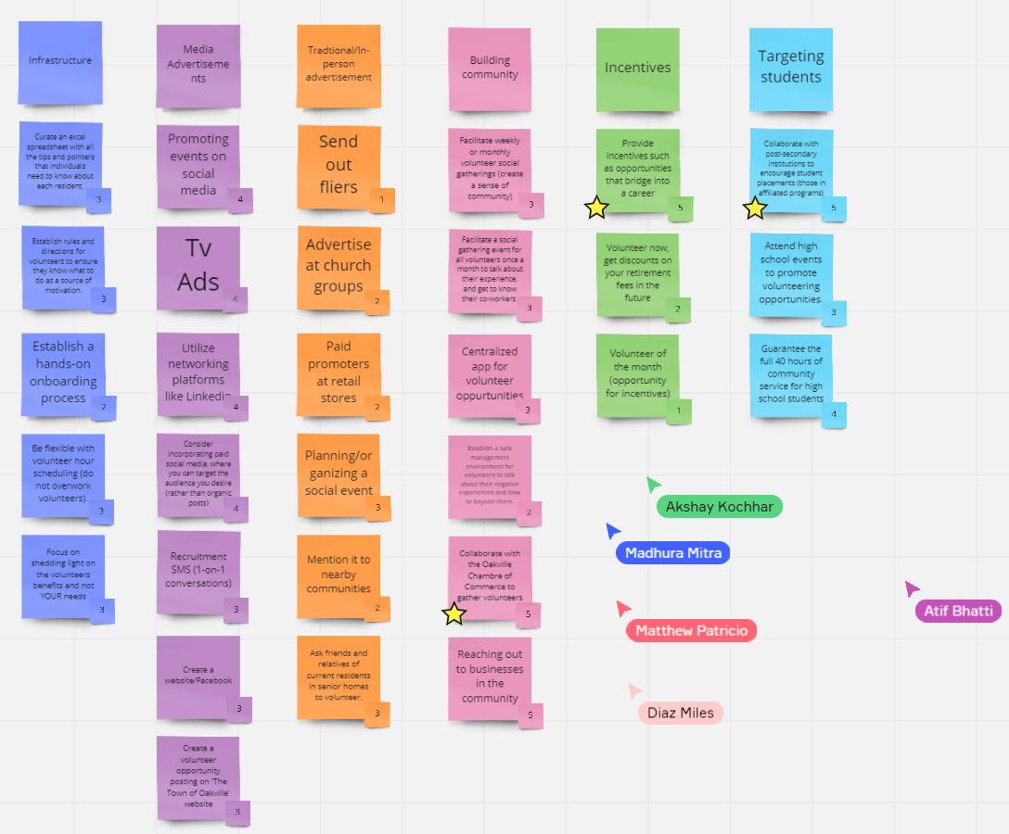
Screenshot taken by: Stephanie Trisic
Step 5. Type your three highest rated ideas in Table 2 below.
- This table contains your team’s top 3 ‘short-list’.

Table 2. Short-list of Possibilities (Top 3)
Top 3 Ideas – Short-list of possibilities
- Collaborate with post-secondary institutions to encourage student placements (those in affiliated programs).
- Collaborate with the Oakville Chamber of Commerce to gather volunteers.
- Provide incentives such as opportunities that bridge into a career.
Step 6. Select one idea that you believe is the best one – The one idea that you could see yourself recommending or doing yourself. Circle or bold it. This is your group’s INNOVATIVE SOLUTION.
Step 7. Retype your INNOVATIVE SOLUTION into Table 3 below.
Table 3. Innovative Solution
Innovative Solution
Collaborate with post-secondary institutions to encourage student placements (those in affiliated programs).

Complete the Reflections on the following page.

Exercise 3: Reflect
Doing the exercises is a good thing but thinking about what just happened is key. This is where the learning sinks in. Answer these questions as a group or through independent reflection if working alone. Point form bullet lists are just fine to use here. Be sure to show authentic engagement. (Aim for 5 thorough points per response)
1. In your process of Clarification and Ideation, what went particularly well? What were some of your successes? (Make a list)
- Maintained truthfulness with one another and were honest with our points of view, thought processes, and opinions to construct the most effective and relevant points and solutions for the project.
- Group flow was established during the diverge stage by being responsive and building on top of each other's ideas.
- Individuals received criticism well and no feelings were hurt during the process. Group members took constructive feedback to improve upon ideas.
- Successfully utilized multiple channels of communication through WhatsApp, Miro Board, Google Docs, and Cisco WebEx, for the most effective flow of group work.
- Group was able to manage meeting times effectively by prioritizing and fully understanding the goals and expectations for the assignment.

2. In your process of Ideation, what did you find particularly challenging? (Make a list)
- The most difficult step in the ideation booklet was narrowing in on at least 5 categories that best suited all 30 of our divergent thinking sticky notes.
- Rating ideas based on how well it answered our question without downplaying other group members’ contributions.
- We found ideas overlapping each other, so we would go back to try to differentiate each idea. Therefore, it would be difficult to think of other unique and different ideas during the diverging stage.
- We had a few good ideas during the converging stage that it was hard for us to come down to one specific solution.
- Difficult to defer judgement when in the divergent stage of the ideation booklet. Each team member wants to “come up with the best idea” when considering the clarified problem.
3. What was particularly useful and would be favourable to use in the future when a problem comes up in your work and personal life? (Make a list)
- Utilizing an intuitive group collaboration software (Miro Board) to track the process of each team member, identify “repeat” ideas, and have everything in one area - much easier to refer back to in the future.
- Consistently utilizing screenshots for “proof” of teamwork.
- Communicating well in advance about meeting times and trying our best to adapt to all group member needs.
- Setting up preliminary documents prior to meeting and “discussing an agenda” to make best use of our time together (being effective and efficient).
- Creating a welcoming, non-judgemental group environment where each individual is understanding of one another's personal lives. Keeping things professional yet cozy.

Development Stage of the Creative Problem-Solving Process
Exercise 1: Formulate possibilities
Now that you have your innovative solution you are set up to formulate possibilities to attain/reach your solution. You are ready for Development.
During development, you will
- Diverge: Generate may options, and then
- Converge: Narrow possibilities
Instructions:
Step 1. To start, carry over and write your innovative solution (from the ideation booklet) in Table 1 below.
Table 1. Innovative Solution
Innovative Solution
Collaborate with post-secondary institutions to encourage student placements (those in affiliated programs).

Step 2. Using the Stick`em Up brainstorming method (brainstorming with post-it notes), come up with 15 potential ideas to attain/reach your solution:
- Reflect on ideas that could address your solution
- As you go, write them on sticky notes on your Google Jamboard, and
- Remember to defer judgement
Step 3. Once you have completed your brainstorming,
- Screenshot/save your array of ideas and paste it here for your master copy of the exercise booklet.
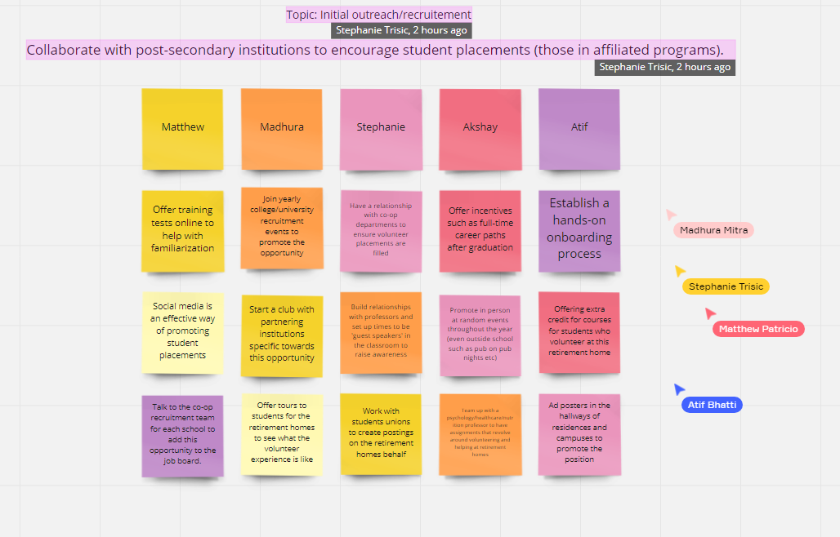
Screenshot taken by: Akshay Kochhar *Diaz received their Covid shot and wasn’t able to make it to the meeting
Exercise 2: Narrow options
In the last exercise, you used divergent thinking (i.e. brainstorming) to come up with lots of potential options to attain/reach your innovative solution.
Next, use convergent thinking to narrow the possibilities.
Instructions:
To start, Get Organized.
Step 1. On your Google Jamboard, and as a team, sort your options into clusters/categories that make sense to you (at least 3 categories)
Step 2. Name each cluster/category, and
- add different coloured post-it notes as headings to your categories.
Next, Evaluate.
Step 3. Rate each option on a scale of 1-5, in terms of IMPACT – how well it would solve your innovative solution. You are rating all 15 ideas on your Google Jam board. Make sure the ratings are clearly visible.
- Note that a rating of 1 = very low impact, and 5 = very high impact
- For example, “online ordering and delivery from Tim Hortons 30 minutes before class (4)”
Step 4. Select one option that you believe is the best one – The one option that you could see yourself recommending or doing yourself. Circle or bold it. This is your group’s INNOVATIVE SOLUTION.
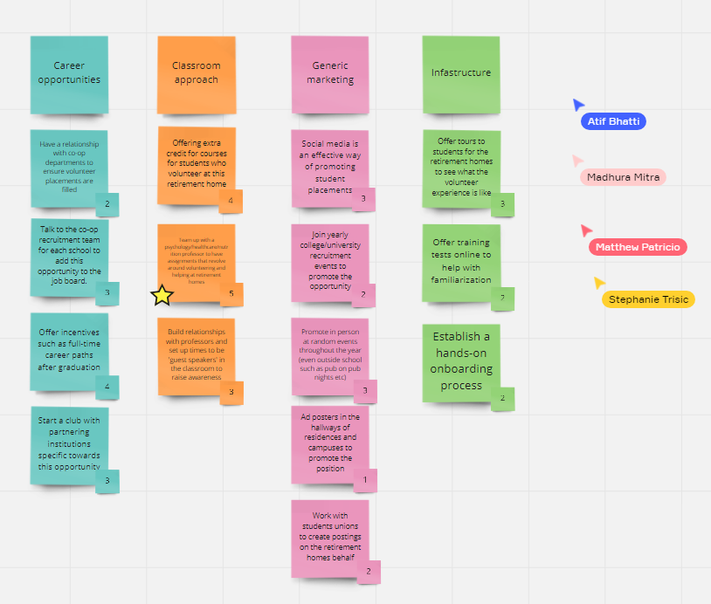 Screenshot taken by: Akshay Kochhar *Diaz received their Covid shot and wasn’t able to make it to the meeting

Step 5. Retype your best option to attain/reach the INNOVATIVE SOLUTION into Table 3 below.
Table 3. Best Option to Attain/Reach the Innovative Solution
Best Idea to Attain/Reach the Innovative Solution
Team up with a psychology/healthcare/nutrition professor to have assignments that revolve around volunteering and helping at retirement homes.

Exercise 3: Reflect
Doing the exercises is a good thing but thinking about what just happened is key. This is where the learning sinks in. Answer these questions as a group or through independent reflection if working alone. Point form bullet lists are just fine to use here. Be sure to show authentic engagement. (Aim for 5 thorough points per response)
1. In your process of Development, what went particularly well? What were some of your successes? (Make a list)
- We were able to use some of the concepts that we thought about in the Ideation stage and mould them to be useful for our particular topic.
- We built off of each other's ideas to improve the points we had already made, so it helped to make our points stronger and more relevant.
- With a lower number of potential ideas to generate, we pushed ourselves to come up with novel, innovative solutions.
- Establishing an aligned vision and common purpose by constantly revisiting our innovative solution and clarified problem.
- Since we were performing a similar task to the prior ideation booklet, we were a lot more efficient with our time. By being familiar with the task at hand and having already performed a similar step by step process, our group was a lot more efficient and effective.
2. In your process of Development, what did you find particularly challenging? (Make a list)
- Some of our ideas were overlapping each other so it was hard to come up with innovative solutions.
- As we continue to narrow in on our ideas throughout the Foursight and the Creative Problem-Solving Process model, we found it be more difficult to diverge our thinking.
- As students, we wanted to make sure that these ideas are something that would attract us to join this opportunity. Therefore, it was difficult to come up with interesting solutions that we knew would catch student’s attention.
- This time around we were missing one group member, so it was tougher to brainstorm with less people. Obviously, six minds are better than five.
- Categorizing our 15 divergent thinking points into at least 3 categories posed some difficulty.
3. What was particularly useful and would be favourable to use in the future when a problem comes up in your work and personal life? (Make a list)
- Organizing our ideas into categories helped us narrow down our thoughts and this is definitely something we could use in the future and/or our work and personal lives.
- Being able to work all together for the project to ensure each member's thought processes were in line with each other to be able to approach the question with similar mindsets.
- Establishing a balance of group members' contributions, by setting up the Miro board with each group member's names with the same amount of ‘sticky notes’ under each.
- Rating each idea that we had so that we can point out the best and worst ideas and not be overwhelmed by everything listed on the Miro board.
- We went about this booklet much easier because of similar tasks in the previous booklet, so practicing this method of creative thinking continuously will allow us to go about problem solving much more efficiently.

Implementation Stage of the Creative Problem-Solving Process
Exercise 1: Formulate a plan
Now that you have formulated the best possibility to attain/reach your solution, you are set up to formulate a plan. You are ready for Implementation.
During development, you will
- Diverge: Generate many options, and then
- Converge: Narrow possibilities
Instructions:
Step 1. To start, carry over and write your best possibility to address your innovative solution (from the development booklet) in Table 1 below.
Table 1. Best Possibility
Best Possibility
Team up with a psychology/healthcare/nutrition professor to have assignments that revolve around volunteering and helping at retirement homes.

Step 2. Using the Stick`em Up brainstorming method (brainstorming with post-it notes), come up with 15 potential actions that will support the implementation of the selected solution:
- Reflect on ideas that could address your possibilities
As you go, write them on sticky notes on your Google Jamboard, and
- Remember to defer judgement

Step 3. Once you have completed your brainstorming,
- Screenshot/save your array of ideas and paste it here for your master copy of the exercise booklet
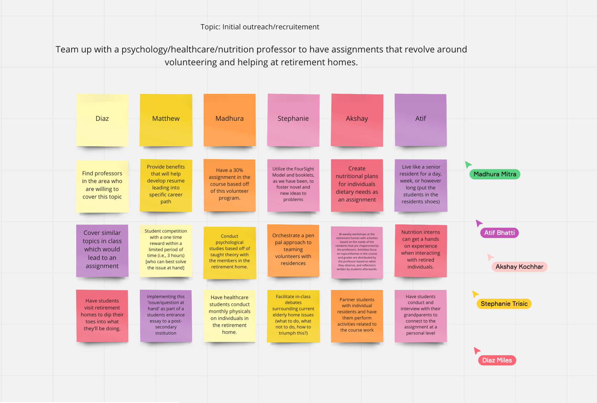
Screenshot Taken By: Matthew Patricio

Exercise 2: Narrow options
In the last exercise, you used divergent thinking (i.e., brainstorming) to come up with lots of potential actions to address your possibilities to attain/reach the innovative solution.
Next, use convergent thinking to narrow the possibilities.

Instructions:
To start, Get Organized.
Step 1. On your Google Jamboard, and as a team, sort your actions into clusters/categories that make sense to you (at least 3 categories)
HINT: Use a stoplight approach. Red light = 5 actions that need to be stopped
Yellow light = 5 actions that need to be continued
Green light = 5 actions that need to be started
Step 2. Name each cluster/category, and
- add different coloured post-it notes as headings to your categories.
Next, Evaluate.
Step 3. Rate each action on a scale of 1-5, in terms of IMPACT – how well it would solve your problem. You are rating all 15 ideas on your Google Jamboard. Make sure the ratings are clearly visible.
- Note that a rating of 1 = very low impact, and 5 = very high impact
- For example, “online ordering and delivery from Tim Hortons 30 minutes before class (4)”
Step 4. Select one action that you believe is the best one – The one idea that you could see yourself recommending or doing yourself. Circle or bold it. This is your group’s best action to attain/reach your INNOVATIVE SOLUTION.
Step 5. Retype your best action to attain/reach the INNOVATIVE SOLUTION into Table 3 below.
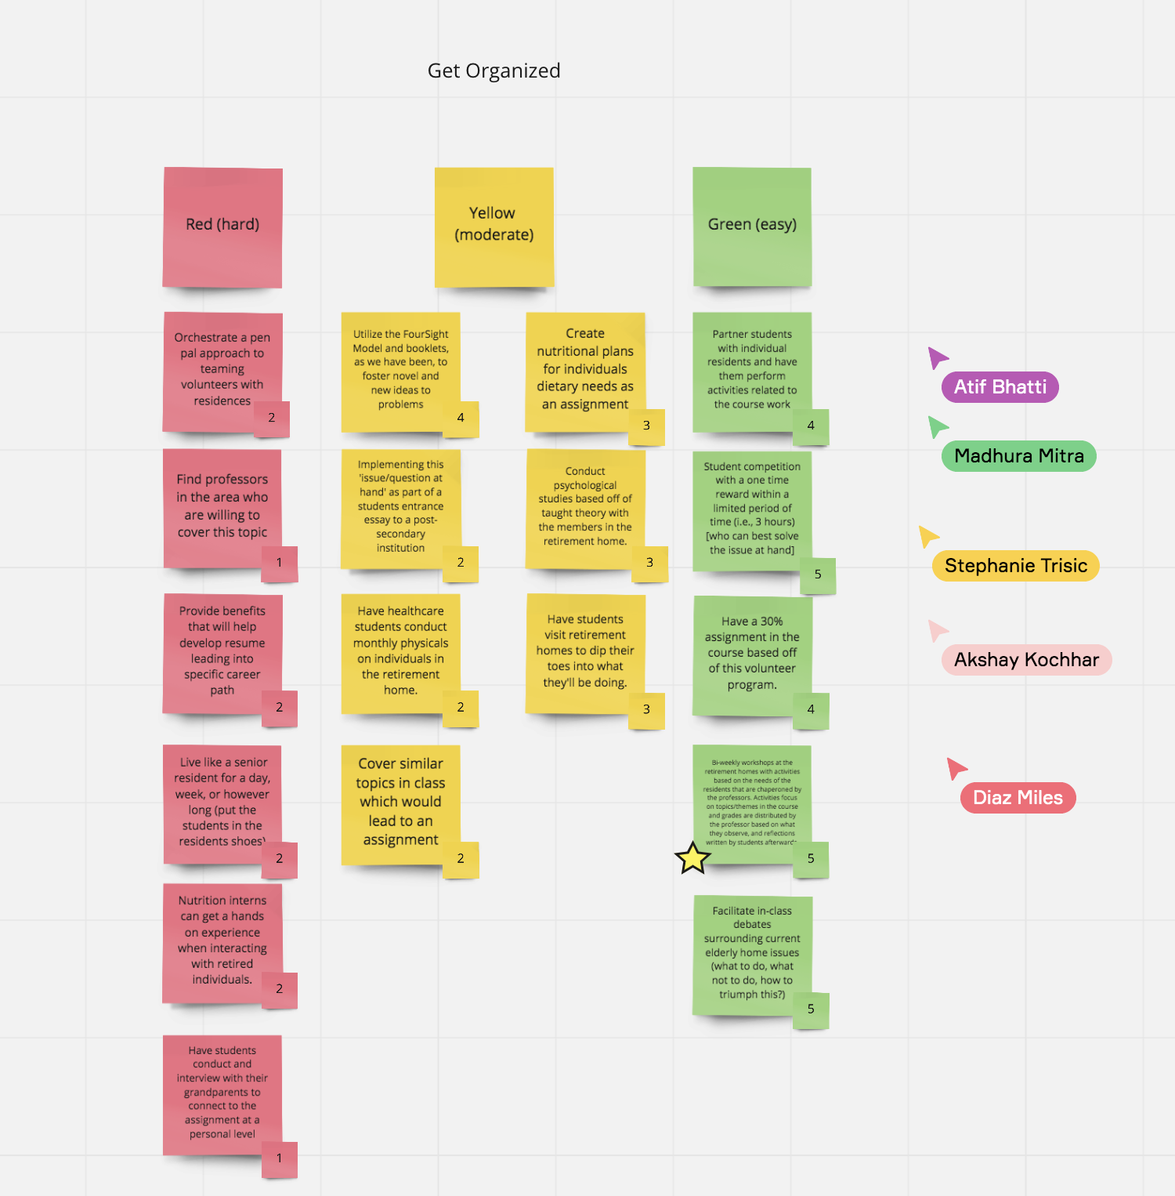
Screenshot Taken By: Matthew Patricio

Table 3. Best Action
Best Action to Attain/Reach the Innovative Solution
Bi-weekly workshops at the retirement homes with activities based on the needs of the residents that are chaperoned by the professors. Activities focus on topics/themes in the course and grades are distributed by the professor based on what they observe, and reflections written by students afterwards.

Exercise 3: Reflect
Doing the exercises is a good thing but thinking about what just happened is key. This is where the learning sinks in. Answer these questions as a group or through independent reflection if working alone. Point form bullet lists are just fine to use here. Be sure to show authentic engagement. (Aim for 5 thorough points per response)
1. In your process of Implementation, what went particularly well? What were some of your successes? (Make a list)
- Working on a project like this together as a team helped us approach the booklet in a more efficient manner rather than splitting up the work between members and completing it in our own time.
- Rating our ideas in the stoplight approach was easier after we sorted them accordingly from the three categories: red (hard), yellow (moderate), and green (easy).
- Group flow was established as all group members contributed to putting forth ideas in each stage.
- Generating more than the required number of ideas, (our creative juices were flowing). Since we have 6 group members, we decided to generate 3 each (with a total of 18). Group members who found themselves generating more ideas than others were assisting other group members with generating their own lists.
- Helping each other in areas where we had trouble was definitely one of our strong suits. For example, we put our heads together and eventually figured out the stoplight approach.

2. In your process of Implementation, what did you find particularly challenging? (Make a list)
- Understanding the stoplight approach was a difficult task as most of us were novice to this approach. We had to do research and alter some of our ideas in the diverge stage to fit the stoplight approach.
- Having to brainstorm fifteen actions for this specific innovative idea was tough because we didn’t want our ideas to be redundant. This was the part that took us the longest in the implementation stage. In the end, we came up with 18!
- Solidifying the last and final ‘innovative solution’ caused great discussion. There were multiple approaches that we could have taken to the initial problem to be solved and coming to a group conscientious on which one was the most attainable, innovative, and easiest to execute caused difficulty.
- Generating ideas with our initial clarified problem, innovative solution, and best idea to attain/reach the innovative solution, in mind. By trying to stay aligned, it was getting more and more difficult to defer judgement as we worked through the booklets.
- Based on the stoplight approach, we found ranking each idea to be a little difficult. We were unsure whether red means that the rank for those respective ideas should be lower compared to others, or whether they can be ranked highly based on our judgement. We ultimately proceeded to give lower ranking to the red criteria considering that these ideas are less feasible or relevant to our topic.
3. What was particularly useful and would be favourable to use in the future when a problem comes up in your work and personal life? (Make a list)
- Again, using the Miro board as a group collaboration platform to track each group members contributions and identify where ‘more attention’ needs to be placed for the success of our teamwork
- Keeping an open and honest relationship with your team. Knowing when enough is enough and identifying when team members are ‘burnt out’. It is better to space out your work then to overwork yourself and get limited results
- Rather than just performing an action or moving onto the next step of a project, it is important to make sure that each team member is there with you. Taking a step back and discussing what is next, why we are doing this step, and how to approach the step - keep a unified mindset.
- Using the stoplight approach is something that would definitely be useful for future projects because it provided a visual and helped us categorize our points based on relevancy and how attainable the solutions are.
- Thinking ahead and making sure we’re taking future steps into account when making decisions for the project

“Two-Page” Pitch - Elder Food Security Challenges
Akshay Kochhar, Atif Bhatti, Diaz Miles, Madhura Mitra, Matthew Patricio, and Stephanie Trisic
SOCS10172GD: Principles of Creative Problem Solving
Patricia Marshall
August 8th, 2021

The Issue:
We have all gone through a very interesting year, where we have realized that the fragmentation of our society is more prevalent than ever. We are recognizing that we need to pay greater attention to our vulnerable members. In this case, our elderly community’s food security. There are two streams in which we are seeing an impact: sources of food and supporting food delivery. Throughout the pandemic, food security has come to the forefront; with disruptions to supply chain efforts, increased food pricing, and an ongoing limitation to our vulnerable community members’ ease of mobility. In this pitch, we will be touching on the support of food delivery, more specifically volunteer engagement. The question derived from this main issue is: how can we find new areas, methods, and means to source and motivate volunteers?
Our Innovative Solution:
Our main idea for the innovative solution is to collaborate with post-secondary institutions to encourage student placements for volunteering positions at the retirement home. The basis behind this idea was that students in affiliated programs are more likely to have an automatic interest in an experience for a volunteering opportunity that is heavily related to their programs. We will do so by teaming up with professors in the psychology/healthcare/nutrition departments to develop course plans that integrate the volunteering experience throughout course theory. Bi-weekly workshops will be implemented to support student volunteering efforts. Each workshop will be directly related to the respective course topics and eventually will be applied in a real-life setting within Knox Heritage Place. These activities will be chaperoned by the affiliated professors and teaching assistants of each course, where grades will be weighed against a student's engagement, heightened interest, and of course an understanding and application of course theory. For example, nutritionist students will work collectively in groups to develop and customize appropriate nutritional plans catered towards a resident's dietary needs and restrictions. Once the nutritional plan is approved, the groups will perform customized shopping, delivering, and cooking of these meal plans on a bi-weekly basis. Not only does this solution help tackle the issue of sourcing, motivating, and engaging volunteers, but also ultimately allows for ongoing support to the overarching problem of supporting food delivery.
Upsides and Risks:
The upsides of this endeavour are that it provides cheap labour for interested parties as well as an overall higher level of volunteer engagement. With this, we can also see an increased awareness of the need for volunteer work in retirement facilities. Since our volunteers are students in affiliated programs, we can expect to see a greater interest in this particular field of work. The most beneficial upside to our innovative solution is that it benefits both the students and residents - provides hands-on experience for the student and individualized care for the elders.
With an innovative solution comes a potential for risks. The following are a couple identified by our team. There may be a cause for professional liability working alongside the residences in different states: whether this is one's physical limitations, language barriers, or mental capabilities. Additionally, due to current Pandemic protocols, this also poses a risk to Knox Heritage Place. Issues surrounding having a sufficient amount of PPE (personal protective equipment) on hand or ensuring that the number of Knox Heritage Place employees to student volunteers does not exceed the number of recommended people permitted in the retirement home.
Spark of Creativity:
Our innovative solution is to carry out bi-weekly workshops at retirement homes with activities and exercises based on the needs of the residents, chaperoned by applicable professors. Activities surrounding these workshops will focus on topics/themes in students' coursework; grades will be distributed by the professor(s) based on what they observe, and reflective assignments performed by the students afterward. With this in mind, our intention with this innovative solution is to eventually have each individual's extrinsic motivation turn into intrinsic motivation. By having a recurring workshop that ties together this volunteer experience and course work, students will put their best foot forward. With an aim to receive the highest mark possible, personal, and emotional relationships with the residents and full-time Knox Heritage Place employees will be formed: creating an intrinsic motivator. Rather than volunteering with the purpose of receiving a satisfactory mark, students will begin performing the workshops and continue volunteering in the future for its inherent satisfaction. All in all, this approach allows us to solve the main issue of being able to offer alternative methods to source and motivate volunteers. With both parties benefiting from this innovative solution, students receiving hands-on experience and residents receiving the proper nutritional care they need, we see an original and useful idea on our hands.

